|  |  |  |
| --- | --- | --- |
| **LAB 321Assignment** | **Type:** | **LongAssignment** |
| **Code:** | **J3.L.P0004** |
| **LOC:** | **400** |
| **Slot(s):** | **10** |

**Title: News Papers**

**Background**

Reading news in the internet now is new trend, especially young generation. We will make a simple digital new websites, where you could find most of digital news.

**Program Specifications**

Program a digital news website, detail functions of this website is described below

**Features:**

This website contains information of digital news

Note: All data must be load from database, not hard code.

***Expectation of User interface:***

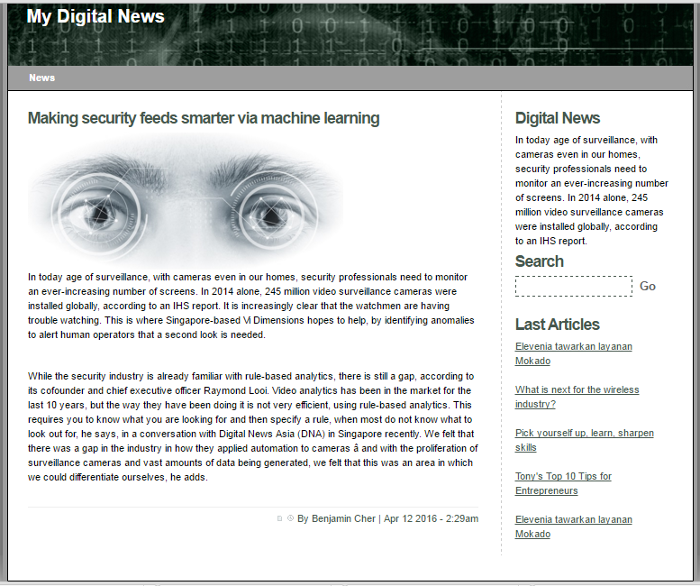

Search news by new title

Top 5 most recent news

The most recent news

Writer and date published

**Guidelines**

* Step 1 : Create prototype
* Step 2 : Design database base on created prototype
* Step 3 : Code & Test